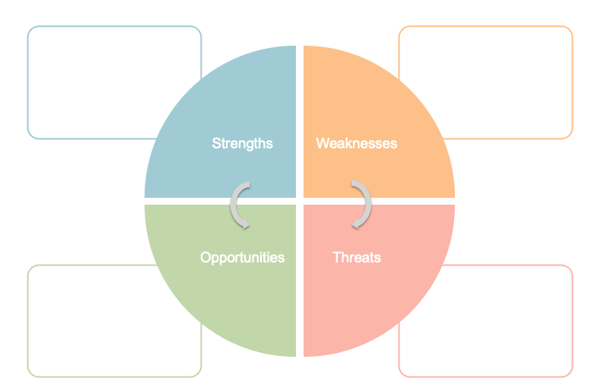

* Prior personal experience of clinically significant fatigue, struggling with recovery, and struggling to remain independent with ADLs
* Little prior knowledge of coaching service users on pacing, besides basic MSK rehabilitation and improving on a sedentary lifestyle
* Gives better insight and ability to empathise with patient suffering from fatigue, and ability to personalise coaching techniques
* Being able to coach pacing for a service user without fatigue (such as with simple MSK rehab or muscle atrophy) does not translate well to coaching pacing for someone with clinically significant fatigue who is struggling with simple tasks such as ADLs or mobilising