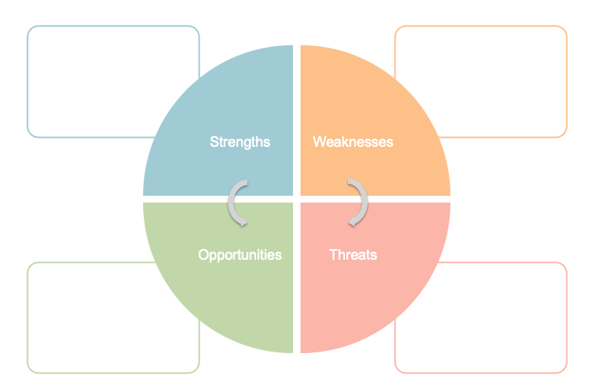

Past Experience - I am fortunate enough to have some past clinical experience in MSK healthcare. This has afforded me experience with patient contact in primary and community care, and understanding of NHS systems in these areas.

Bad habits – Sadly past clinical experience has a risk of bringing bad habits. This may come in the form of cutting corners, adopting local cultures, or viewing some processes as “less important” because I have done them before.

Secondary care – I have no experience whatsoever of secondary care, or clinical problems that are too acute or complex to be managed in primary care, as sadly there is a lack of feedback once these cases have been referred on or they do not present to primary care in the first place.

Uni – opportunities to learn from taught content, self-directed learning, and from other students

FCP Clinic – I am fortunate enough to be able to run one clinic a week, maintaining my current skills and gaining clinical experience and exposure

Clinical Tutor role – I have recently been employed as a clinical tutor, which will afford me the opportunity to learn through teaching others, and establish personal and people development skills

Placements – There are opportunities for further personal development via two student placements as part of our course. The first will be with the CSP, and the second is TBC.

Distraction – I currently have quite a few different plates to spin whilst also being enrolled in full time education. There is a risk that distraction may inhibit me from achieving my development goals

Time management – For the same reasons, I must be mindful to manage my time well in order to achieve my development goals.

Complacency – A quality a very much do not like about myself is that I can become complacent if I think I know something already. This quite frankly is intellectual arrogance, and I must recognise this knee-jerk reaction in myself and diminish it before it becomes threat to my own personal development