Photo | Description | Name of Lesion
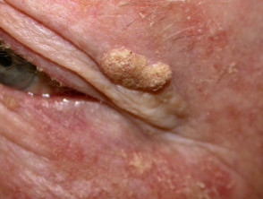 | 8mm x 4mm oval-shaped but asymmetrical nodule with a well-defined border. This is a single lesion just below the lateral end of the left eyebrow, and is non-pigmented. It is rough with a wart-like surface, and “stuck on” appearance. | Seborrhoeic Keratosis (benign, but can be curettage if uncomfortable or impacting QOL)
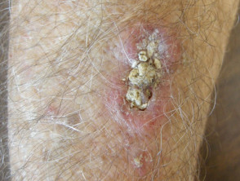 | 20mm x 6mm oval-shaped asymmetrical lesion with an irregular border. This single lesion is on the extensor aspect of the right forearm, and has a raised pink rim with a well-established keratin plug. The patient reports that the lesion is itchy and often bleeds, but no ulceration is apparent on examination today. | Squamous Cell Carcinoma (malignant)
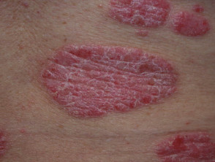 | 60mm x 40mm asymmetrical plaque with a well-defined border. This is the largest of multiple randomly distributed lesions on the patient’s back, all of which have similar appearance. The lesion is red with a dry, silvery, scaley appearance. The patient reports that the lesions are severely itchy but do not bleed easily, no ulceration is apparent on examination today. | Psoriasis (benign, but requires non-urgent referral for management)
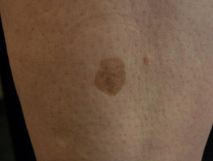 | 4mm x 4mm relatively symmetrical macule. The lesion is of uniform light-brown pigment, has a well-defined border, and has the same texture as the surrounding skin. It is a single lesion and is located on the shin, at approximately 1/3 down the length of the tibia. The patient reports that this lesion is asymptomatic. | Solar Lentigo (benign)
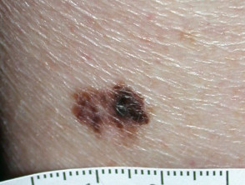 | 10mm x 6mm asymmetrical lesion with an irregular and poorly-defined border. The lesion is pigmented with 3 different shades of brown, and has a similar texture to the surrounding skin. The majority of the lesion is flat, although one area appears to be slightly raised. This single lesion is location on the patient’s upper chest, approximately 3cm inferior to the medial end of the clavicle. No ulceration is apparent on examination, and the patient reports that the lesion does not itch or bleed. The patient does however report that the lesion has been changing in appearance over the last few weeks. | Malignant Melanoma (malignant)
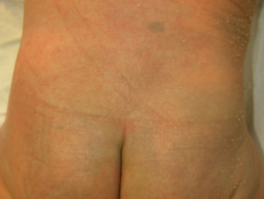 | 10 x 8mm macule just to the right of the midline, approximately 7cm superior to the gluteal crease. This lesion is symmetrical with a well-defined border, is blue/grey in colour, and has the same texture as the surrounding skin. Mum reports that this mark has been unchanged since birth, and does not cause baby any obvious signs of discomfort. | Slate grey naevus / Mongolian blue spot (benign but monitor to rule out bruising)
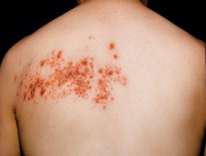 | Vesicular rash in a dermatomal distribution at T1 on the left. It does not cross the midline, and does not appear in any other distributions. The rash is red in colour and excoriated in appearance. The patient reports that the rash is intensely itchy, and came on after a period of feeling systemically unwell. | Shingles (benign, but should be referred to GP for management)

All photos courtesy of dermnetnz.org

