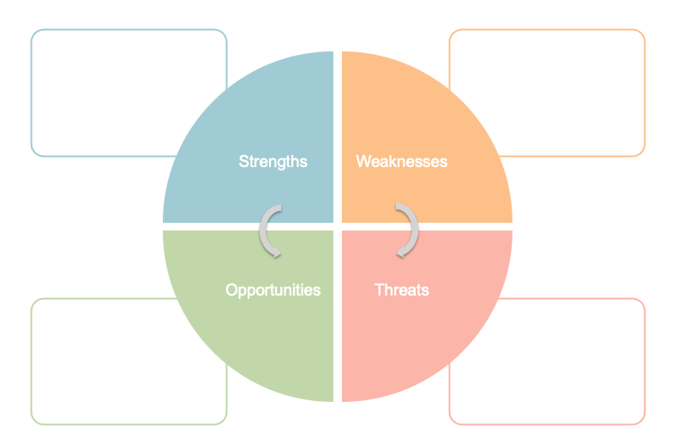

* Previous experience of seeing patients with non-MSK conditions presenting in a similar way to MSK pain
* Long period of time away from clinical contact
* Diminished diagnostic confidence
* It is in the forefront of my mind still that the most important factor for patient safety is to triage non-MSK from MSK conditions, despite location of pain
* Opportunity to refresh and expand on existing knowledge rather than learning from scratch
* Reduced likelihood of asking key differentiating questions, of what symptoms might present alongside pain which moves the working diagnosis away from MSK, and of asking safety netting questions
* Reduced likelihood of recognising red flags and/or missing urgent diagnoses such as CES of neoplasm