**Frailty Notes**

Weakness

* Not understanding the difference between age and frailty
* Not knowing how to define frailty
* Not knowing how to assess frailty

Learning points

* Frailty is not an inevitable part of ageing, it is considered a LTC or health state in its own right
* Recognising frailty reduces the risk of deconditioning, unnecessary hospital admission time, and inappropriate treatment
* Two main models of understanding frailty: the Phenotype model; and the Cumulative Deficit model.
* The Phenotype model defines frailty as a person having 3 or more of the symptoms below:

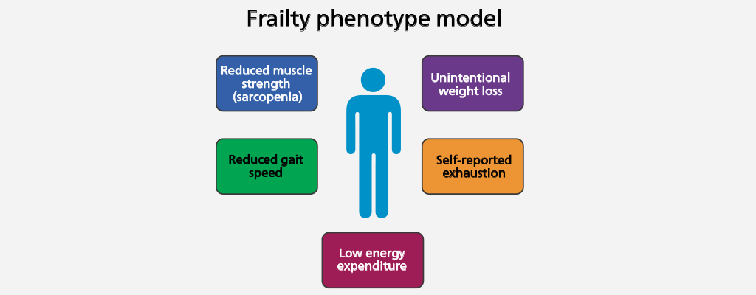

* The cumulative deficit model views frailty in terms of increasing threat when weighed up against capacity, increasing the frailty index
* Frailty indices could be the eFI (electronic frailty index) or CFS (clinical frailty state).
* The eFI categorises people in to not frail, mildly, moderately, or severely frail categories and uses disease states, a series of symptoms, disability, and abnormal test results as variables. It is used more in primary care
* The CFS is used more in secondary and community care, and places a person in to one of 9 categories: Fit (the person is active with no LTCs), Well (inactive but with no LTCs), Managing well (has one or more LTCs but able to manage them effectively, very mild frailty (beginning to lose independence), mild frailty (needs help with demanding ADLs), moderate frailty (needs help with outdoor activities and most ADLs), severe frailty (needs help with all ADLs), very severe frailty (approaching end of life, could not recover from minor illness), terminally ill (life expectancy <6mo).
* If a person is identified as living with frailty with CFS score of 5 or above, a comprehensive geriatric assessment (CGA) is undertaken. This is an MDT assessment involving geriatricians, nurses, pharmacists and other therapists, in order to optimise their illness, identify their goals, and create an individual care plan. It includes physical, psychological and functional assessments. Those with a score of 4 or less should be signposted to community services to aid their self management
* **The five main symptoms of frailty are:**
  + **Falls**
  + **Decreased mobility**
  + **Confusion/Delirium (delirium is associated with 40% mortality rate within 1 year of onset, even if it resolves)**
  + **Incontinence**
  + **Susceptibility to side effects of medicine (medicine reviews are carried out by pharmacists and assess for interactions, correct dosages, manageability, and discontinuing those no longer required)**
* Delirium is an important clinical symptom as it is associated with a 40% mortality rate within 1 year on onset, even if it resolves. It can be hypoactive (people become withdrawn and quiet), hyperactive (people can be distressed, agitated and aggressive), or mixed. Delirium can involve hallucinations and paranoia, and can be a sign of infection, dehydration and hypoxia.
* Supporting self management of frailty can involve reducing social isolation, managing medicines, physical and psychological support, and introduction of assistive technology