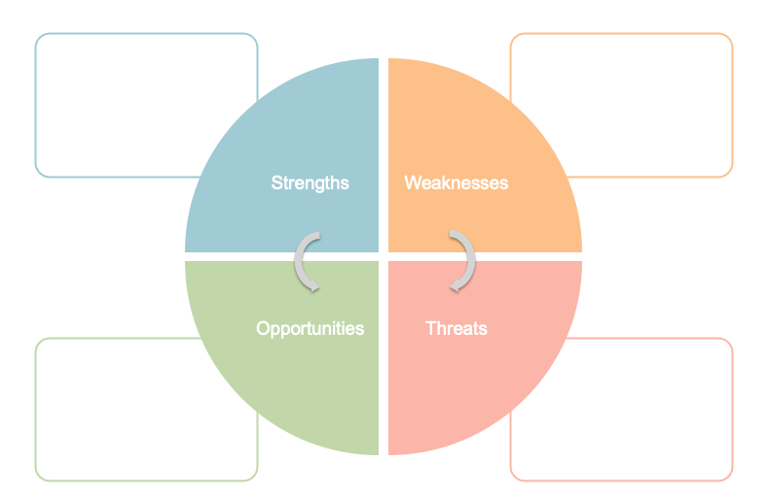

* Prior clinical experience
* Prior experience of clinical reflection
* No experience of challenging ethical dilemmas in practice
* Ability to critically analyse and reflect on decision-making rather than rely on knee-jerk reactions
* Able to recognise that my lack of experience and ability to contextualise ethical dilemmas means that use of a toolkit could help to better understand the most appropriate approach to decision-making
* Learning about managing dilemmas “as new” for the first time makes it difficult to put in to context as I have no prior frame of reference