**Exploring ethical dilemmas using the British Institution of Human Rights (BIHR) flowchart**

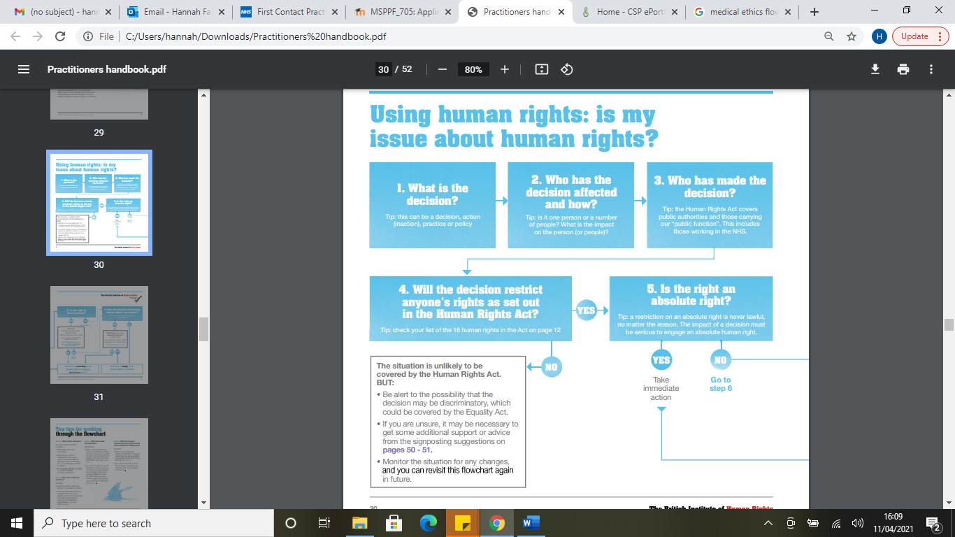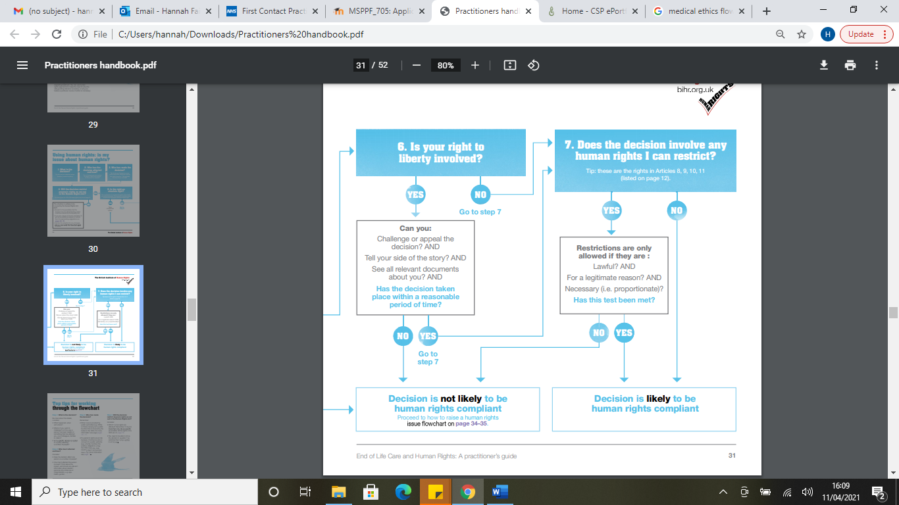

**First case – Charlie Gard**

This case came to light in 2017, due to the disagreement between Great Ormond Street Hospital and Charlie’s parents (Charlie was born with mitochondrial DNA depletion syndrome). The disagreement was regarding whether or not experimental nucleoside therapy was in Charlie’s best interest. His parents wished to proceed with treatment, but GOSH believed it would provide no benefit and may prolong his suffering. At the time of the disagreement, Charlie was failing to thrive, was not conscious, and was reliant on mechanical ventilation.

In February 2017, Charlie’s parents crowdfunded the money to pay for a transfer to New York in order to proceed with nucleoside therapy, but GOSH asked the British High Court to override this decision. It is at this point that we will examine the ethics of GOSH’s decision using the flowchart.

1. To intervene on parents’ decision to transfer Charlie to New York for experimental treatment
2. This decision affects Charlie, as it will result in him not receiving treatment that has the chance to help his condition. It was the clinical consensus at the time, however, that the balance of risk and benefit in Charlie’s case was heavily in the favour of not proceeding with treatment. This decision also affects the parents, in that it will likely cause them great distress.
3. The decision was made by medical staff at GOSH
4. Yes, this decision affects Charlie’s right to life under article 2, as it withholds the only treatment option in an otherwise terminal condition.
5. Yes, article 2 is an absolute right.

This leads to the flowchart result that a human rights issue must be raised immediately, as the decision is unlikely to be human rights compliant.

At this point in the case, the British court was in support of GOSH, but the parents chose to appeal this to the Court of Appeal, the Supreme Court, and the European Court of Human Rights. The guidance of the BIHR suggests that the lattermost appeal was absolutely correct, as a human rights issue should be raised immediately. Perhaps at this point, GOSH could have considered supporting the parents in raising a human rights concern in order for the case to be thoroughly examined, even though they were not in agreement with it.

Charlie’s case is considered to be a landmark or “stigmata” case for the re-examination of current laws, ethics and cultures surrounding the issue at hand. The European Court of Human Rights eventually supported GOSH’s position and deemed that withdrawal of life support was in Charlie’s best interest. He was moved to a hospice and passed away on 28th July 2017

**Second case – Diane Pretty**

Diane Pretty suffered from motor neurone disease and wished to end her life. Due to physical disability, she was not able to commit suicide herself. In early 2002, she wished for her husband to assist her suicide and not be prosecuted, contrary to the Suicide Act of 1961. Diane chose to take her case to the Director of Public Prosecutions to ask that no one assisting her suicide be prosecuted, using articles 3 and 8 of the Human Rights Act 1998 (3 – freedom from torture, inhumane or degrading treatment; 8 – Respect for private and family life). British Courts did not accept Diane’s arguments. It is at this point that we will examine their decision.

1. To deny granting Diane’s husband immunity from prosecution for committing her assisted suicide.
2. This decision affects Diane, as it will prolong her suffering from a progressive terminal disease. It also, however, prevents her from suffering an unlawful death (upholds Article 2).
3. The British Court
4. The court would likely argue that this decision does not affect Diane’s human rights. In terms of article 3, she is not being subjected to torture, inhumane or degrading treatment, as this is the natural course of the disease she is sadly suffering with, and it is not being inflicted upon her by a person, people, or an institution. In term’s of article 8, this is not an absolute right, as it can be restricted in the best interest of the involved person or others.

At this point in the BIHR flowchart, we reach a result that this decision does not affect human rights, however, caution should be exercised in that the decision may be discriminatory. Potentially it could have been argued at the time that, as suicide is lawful for those who commit it, it is discriminatory to deny this option to those who are disabled. It is unfortunate that this was not argued in court at the time. Diane sadly passed away on 11th May 2002.

**Third case – Ashya King**

Ashya was five years old in 2014, when he had successful surgery to remove a medulloblastoma at University Hospital Southampton. Radiotherapy was suggested to follow his procedure, but his parents refused this due to their worries regarding risk and side effects. They felt that the risks and side effects of proton beam therapy were less, and wished for this option instead. Ashya did not meet the criteria for NHS funding for proton beam therapy, as it would give no added benefit, and carry no less risk when compared to radiotherapy. This was communicated to the parents, who proceeded to take their son from hospital without telling medical staff. At the time of being taken from hospital, Ashya had a nasogastric tube in situ, for which he was dependent on for all feeding. His parents were not trained in how to feed him with it. Ashya also had no gag reflex, and his parents were not trained what to do in the event of choking. Ashya was also clinically vulnerable at the time, partly due to his recent surgery, but primarily due to the fact he had spiked a fever the day before his parents removed him from hospital, so there were concerns that he may have an infection. Lastly, Ashya was due to start chemotherapy the next week, for which delays in commencing could result in poorer chance of survival. For these reasons, staff at UHS phoned the police. An international arrest warrant followed this, which lead to his parents’ arrest in Spain 2 days later. The decision of UHS staff to phone the police, rather than respecting the parents’ wishes to refuse Ashya the recommended treatment plan, will be examined using the BIHR flowchart:

1. To disregard Ashya’s parents’ wishes and contact the police.
2. This affects Ashya’s right to life (article 2) as he is in immediate danger of harm being outside of hospital whilst clinically vulnerable, and reduced rate of survival if delays to commencing chemotherapy are incurred. This also affects Ashya’s parents as their wishes are not being respected.
3. Staff at UHS made this decision
4. This decision upholds Ashya’s human rights rather than restricts them.

Again this gives us the result that this decision is unlikely to affect Human Rights, however, it may be discriminatory. Had Ashya’s immediate wellbeing and future clinical outcomes not been in jeopardy by removing him from hospital, then the decision to contact the police may have been discriminatory against his parents’ choices to seek alternative treatment plans.