* Sympathy vs empathy.

Communicating with nor verbal people without patronising them? Saw one non-verbal patient be seen by two different physios, one spoke to him like a child and the other like an adult. He only had very subtle reactions but im sure he understood being spoken to as an adult. He couldn’t laugh but he would make a laughing face at complex jokes. Felt sorry for him being spoken to slowly, clearly and in simple language, but I appreciate the physio was just trying to make sure he understood.

Ask questions rather than make recommendations. “I’d recommend this support cushion for you because you list to the right” vs “I can see that you list to the right, you might benefit from a cushion to support you on that side, is that something youd like to try?”. Helps to frame context, involve hem in decision making and build rapport.

Remember that patients are likely to be anxious at first, so might need to be made to feel at ease as a first port of call. Offer them a glass of water if appropriate, instantly says “I care about you and want you to feel comfortable”. Ask them how their week has been, humanises the conversation. – Patient interview responses

People often spend time before an appointment thinking of things they want to say and questions they want to ask. Give them an opportunity to verbalise these, as a lot of what they take away from the conversation may be focussed around these areas.

Try not to verbalise comparisons of patients experiences to your own, this can make them feel like you are trivialising what they are going through, you don’t understand what it means to them, or that you are more concerned about your own problems than theirs.

**Sympathy**

There are two meanings for sympathy:

1. **Thinking about how you would feel if you were in the same situation as the other person.**
2. **When you see that someone is sad, feeling compassion and wanting to comfort the person.**

**“Empathy**

Trying to understand and appreciate another person's feeling and their experiences without comparing it to your own situation.”

“I know how you feel.”

“I completely understand how you're feeling.”

Show sympathy and not empathy. These might be offensive if said to a relative of someone who is dying. Instead say something like:

“It must be difficult for you.”

“I can see that you're upset.”

This is one way we can show empathy.

Patients can be easily overwhelmed by lots of information or information that is difficult to process (bad prognoses etc), give opportunities for breaks where possible.

Don’t make assumptions on how the other person is feeling, this is not showing empathy. Eg if someone tells you their mother has just died:

“Im so sorry. My father died last year so I know what youre going through” – sympathetic, but assumes their feelings.

“Im so sorry. How are you feeling?” – empathetic, explores their feelings and identifies their specific needs.

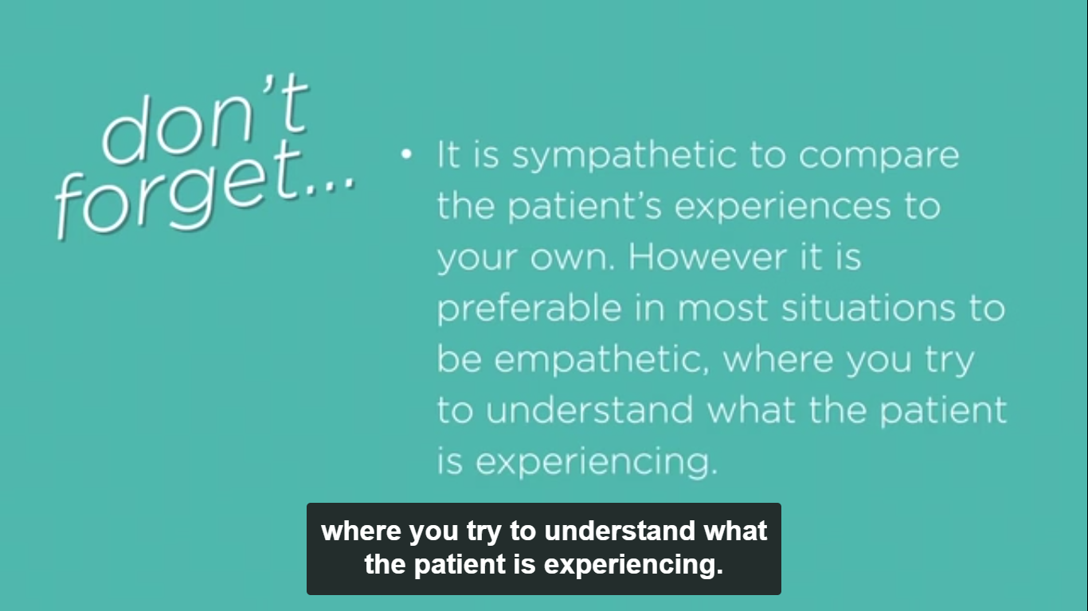

Seek permission for everything you do, as it shows you are appreciating the other person’s values and making an effort to work out what they are and aren’t comfortable with.

The physio that spoke to the patient like a child had a sympathetic relationship with him. She was very caring but she had made assumptions about his needs. The physio who spoke to him like an adult had a more empathetic relationship with him, and had discovered what his needs were, and that he was able to understand more complex communication.